Report for: | Planning Policy Advisory Panel
Date of Meeting: | 3 October 2022
Subject: | Proposal to consider three areas for Conservation Area Status
Key Decision: | No (information report only)
Responsible Officer: | Viv Evans, Interim Chief Planning Officer.
Portfolio Holder: | Councillor Marilyn Ashton, Deputy Leader of the Council, Planning & Regeneration Portfolio Holder
Exempt: | No
Decision subject to Call-in: | No
Wards affected: | West Harrow, Harrow Weald, North Harrow
Enclosures: | Appendix 1 - maps of areas to be considered for conservation area status.

Section 1 – Summary and Recommendations
This report sets out the intent of the Local Planning Authority to consider as possible conservation areas three areas as shown in appendix 1 i.e.

(i) Butler Avenue and surrounding roads in West Harrow (map 1),
(ii) West Drive Gardens, Bellfield Avenue and West Drive numbers 1- 41 (odd) and 2-36 (even) in Harrow Weald (map 2), and
(iii) Suffolk Road in North Harrow (map 3).

These areas have been identified based on requests from residents within the areas.

The criteria that will be used in the assessment are identified, as well as the proposed timeframes for its completion.

Recommendations:

The Planning Policy Advisory Panel is requested to: note the areas to be considered for conservation area status and provide any comments.

Reason:
Conservation Areas are designated under the Planning (Listed Buildings and Conservation Areas) Act 1990 (‘the Act’) which states in section 69 that 'every local planning authority shall from time to time determine which parts of their area are areas of special architectural or historic interest the character or appearance of which it is desirable to preserve or enhance, and shall designate those areas as conservation areas'. Consideration of the three areas as possible conservation areas therefore fulfils Section 69 of the Act.

Section 2 – Report

1.0 Introduction

1.1 The report incorporates the corporate priority concerning:
- Making a difference for communities

1.2 Should the areas meet the criteria for conservation area status, the improved protection of identified areas of special architectural or historic interest will help maintain the unique historical local character of areas or neighbourhoods within Harrow which residents cherish and value.

2.0 Options considered

2.1 The option of not reviewing these areas was considered but this would be contrary to the Council’s statutory obligations under the Planning (Listed Buildings and Conservation Areas) Act 1990, under which local planning authorities are required to carry out reviews ‘from time to time’ to ensure areas are adequately protected.

2.2 Paragraph 3.7 below identifies an alternative option to designation as a conservation area, should the assessments determine an area does not meet the requirements to be designated a conservation area.

3.0 Background

What is a conservation area?

3.1 Conservation Areas are designated under the Planning (Listed Buildings and Conservation Areas) Act 1990 which states in section 69 that 'every local planning authority shall from time to time determine which parts of their area are areas of special architectural or historic interest the character or appearance of which it is desirable to preserve or enhance, and shall designate those areas as conservation areas'. The request therefore represents an opportunity to consider whether the three areas identified represent areas of special architectural or historic interest (the nationally statutory tests for the designation of a conservation area).

3.2 Harrow has adopted four Supplementary Planning Documents (SPDs) that cover the borough’s existing conservation areas. Those documents include local guidance as to what is considered to represent ‘special architectural or historic interest’ in the Harrow context. In order for an area to be appropriate designation as a conservation area, it must fulfil two of the following criteria (as outlined in the SPDs):

(a) Areas with a high concentration of Listed Buildings, whether statutorily or locally listed;
(b) Areas of historical, social, economic and/or architectural merit;
(c) Areas with a high proportion of buildings built prior to 1920, which remain largely unaltered;
(d) Areas built post 1920 that are innovative in planning or architectural detail, and where a large proportion remain unaltered;
(e) A significant group of buildings with distinct physical identity and cohesiveness;
(f) Areas which have a special quality, where the site layout and landscaping are of exceptionally high quality and/or contain historic open space, natural landmarks, topographical features or features of local distinctiveness

When not to designate?

3.3 The National Planning Policy Framework (NPPF) (2021) states in paragraph 191 that:

‘When considering the designation of conservation areas, local planning authorities should ensure that an area justifies such status because of its special architectural or historic interest, and that the concept of conservation is not devalued through the designation of areas that lack special interest’.

3.4 Historic England are the Government’s advisers on matters of heritage. They have published guidance entitled: ‘Conservation Area Appraisal, Designation and Management Historic England Advice Note 1’ [HEAN 1] (Second Edition) – February 2019. They highlight the above requirement of the NPPF twice in their guidance since it was also contained in earlier iterations of the NPPF.

3.5 In addition, HEAN1 mirrors the requirements of s.69 of the Act that there shall be both ‘special interest’ and ‘desirability to preserve or enhance’ for CA designation as it states in paragraph 11 that there is: ‘likely to be a stage when a decision would need to be taken as to the significance of an area and the likelihood of conservation area designation addressing relevant problems within the area. This is unlikely to be a lengthy process, the purpose being to consider whether an area has:
a) sufficient architectural or historic interest for the area to be considered ‘special’?
b) whether this is experienced through its character or appearance? and
c) whether it is desirable for that character or appearance to be preserved or enhanced, and what problems designation could help to solve’.

3.6 Thus, it indicates that where an area meets the criteria for designation, on occasion designation may not be desirable and prompts consideration as to what problems designation could help solve in order to determine the desirability of designation.

3.7 Conservation Areas are a heritage designation governed by national legislation and the principle of what makes an area ‘special’ needs to be considered in the national context; it is therefore a high threshold. Conservation area designation also reduces permitted development rights (i.e. what can be done without planning permission). At a local level, unlike many Local Planning Authorities, Harrow currently does not have a local form of area designation based on the architectural and / or historic interest of an area (a similar concept to Harrow’s ‘Local List’ of buildings compared to statutory listed buildings, which are designated at a national level).

3.8 Depending on the outcomes of the assessments proposed in this report, an option for any area/s considered not to meet the requirements to be designated a conservation area could be for those to be formally identified as having local architectural and / or historic interest. This would not change permitted development rights but would be a material consideration for any planning applications that are received within the area. Such a potential local approach would be developed further and reported in any subsequent report to the Panel as appropriate. Such an approach could also be potentially applied to other areas in the borough.

4.0 Areas to be considered

4.1 The three areas to be considered for designation as conservation areas are shown in Appendix 1 and are as follows:

- Butler Avenue and surrounding roads in West Harrow (map 1)
(b) West Drive Gardens, Bellfield Avenue and West Drive numbers 1- 41 (odd) and 2-36 (even) in Harrow Weald (map 2), and
(c) Suffolk Road (map 3).

4.2 These areas have been identified by the Planning & Regeneration Portfolio Holder based on requests from residents within the areas.

5.0 Process and timeframes

5.1 The assessments will be undertaken by the Planning Service. It is anticipated the assessments and recommendations will be reported to this Panel at its next meeting (anticipated to be late November 2022).

5.2 Any subsequent report to the Panel will outline next steps based on the outcomes of the assessment.

Ward Councillors’ comments – to be sought as part of the assessment

Risk Management Implications

Risk included on Directorate risk register? No

Separate risk register in place? No

There are no significant risks arising from the recommendations – information report only.

Legal Implications

The Council has a statutory duty and is required under section 69(2) of the Planning (Listed Buildings and Conservation Areas) Act 1990 to carry out reviews ‘from time to time’ to determine whether any parts or further parts of their area should be designated as conservation areas; and if it so determines, that part(s) shall be so designated.

Financial Implications

The costs of making undertaking the assessment of the three areas would be met from within the existing revenue budgets of the Council’s Planning Policy team.

Equalities implications / Public Sector Equality Duty

Was an Equality Impact Assessment carried out? No

EqIA is not considered necessary in respect of the making of an Article 4 Direction. Such a proposal is based on the architectural and historic merit of an area and in this particular instance, seeking to correct a legal anomaly. Furthermore, the higher order Local Plan policy that contains the criteria against which development within Conservation Areas is assessed was subject to an equalities impact assessment prior to its adoption. Any potential equality implications of a specific proposal would be addressed during the assessment of the planning action necessitated by the marking of the proposed Article 4 Direction.

Council Priorities

The decision sought will help the Council meet the priority of improving the environment by helping ensure the attractiveness of the borough as a place to live and demonstrating that the Council seeks and listens to the views of its residents.

Section 3 - Statutory Officer Clearance

Statutory Officer: Rikita Panesar / Jimmy Walsh
Signed on behalf of the Monitoring Officer

Date: 22 September 2022 – by email
Chief Officer:
Signed off by the Chief Planning Officer
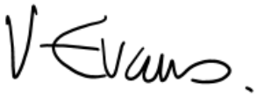
Date: 22 September 2022

Mandatory Checks

Ward Councillors notified: NO – to be sought as part of assessment process

EqIA carried out: NO - information report only
If ‘NO’ state why an EqIA is not required for Cabinet to take a decision

EqIA cleared by: N/A

Section 4 - Contact Details and Background Papers
Contact: Lucy Haile, Principal Conservation Officer, 0208 736 6101, lucy.haile@harrow.gov.uk
Background Papers:
Harrow Conservation Areas and Supplementary Planning Documents (SPDs) - https://www.harrow.gov.uk/planning-developments/biodiversity-conservation

Appendix 1 – maps of areas to be considered for Conservation Area Status

Map 1 - Butler Avenue and Surrounding Roads ie Butler Avenue (all), Butler Road (all), Bessborough Road (24-42 – even), Vaughan Road (1-55 – odd). West Harrow
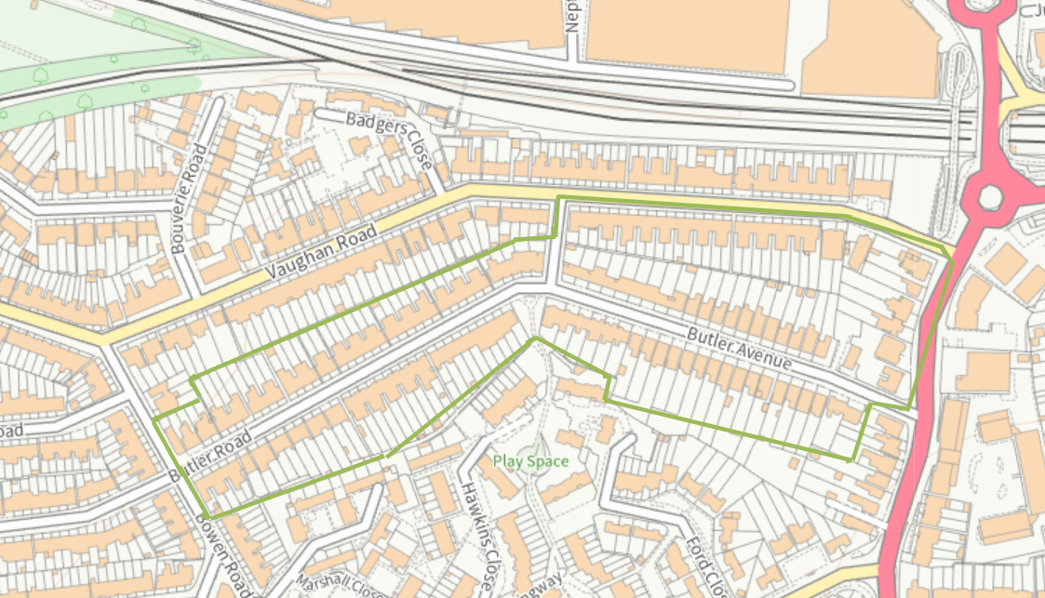

May 2 - West Drive Gardens, Bellfield Avenue and numbers West Drive1- 41 (odd) and 2-36 (even), Harrow Weald
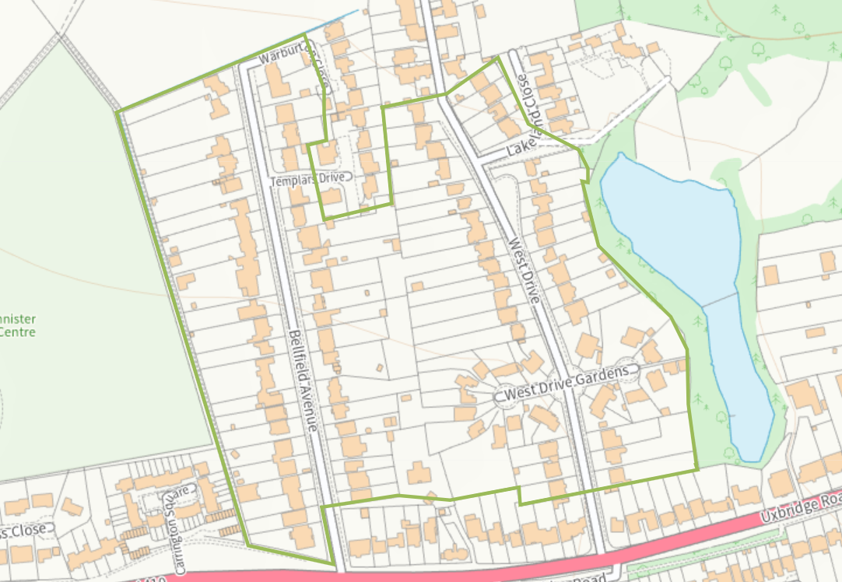
Map 3 - Suffolk Road, North Harrow
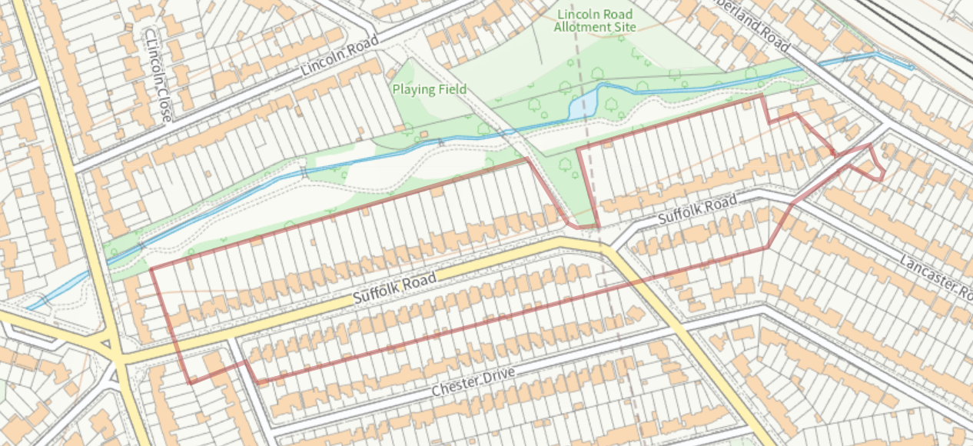

These criteria were originally agreed by the Development Control Committee on 31 August 1998 as the criteria to be adopted in Harrow.

